# Graphics Output on the hsafx Console

## Introduction

You already know that the Console window can output text, laid out in rows and columns of **characters** (any letter, number, punctuation mark, space, etc. is a character).

But the Console can also output graphics, and for that you have to think of it as laid out in rows and columns of **pixels** (a pixel is the smallest dot of color that can appear on a computer screen).

## Graphics Output

For graphics, the console is divided into **x and y coordinates**. Each x and y coordinate identifies a single pixel. The top left corner is x=0 and y=0. Whenever you draw a shape, you usually have to specify an x and y starting position, and at least a width and height for the shape, in pixels.

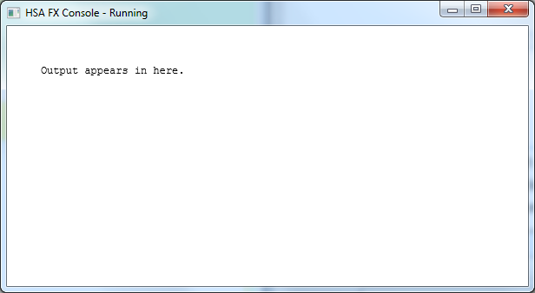

x coordinates increase from left to right

y coordinates increase from top to bottom

x = 0, y = 0

x = 30, y = 30

height = 100 pixels

width =

150 pixels

## Basic Graphics Methods

There are two kinds of drawing commands. Commands that start with “stroke” draw outlines, and commands that start with “fill” draw filled-in objects.

**c.setFill(*“color”*)**

Sets the color for all “fill” drawing commands.

**c.setStroke(*“color”*)**

Sets the color for all “stroke” drawing commands.

**c.setLineWidth** (width)

Sets the width of the line for all “stroke” drawing commands.

**c.fillRect** (x, y, width, height)

Draws a filled rectangle with upper-left corner at (*x*, *y*) with width of *width* and height of *height*.

**c.strokeRect** (x, y, width, height)

Draws a rectangle outline with upper-left corner at (*x*, *y*) with width of *width* and height of *height*.

**c.fillOval** (x, y, width, height)

(*x*,*y*)

*height*

*width*

Draws a filled oval. The oval is inscribed in the rectangle defined by the upper-left corner (*x*, *y*) with width of *width* and height of *height*.

**c.strokeOval** (x, y, width, height)

Draws an oval outline. The oval is inscribed in the rectangle defined by the upper-left corner (*x*, *y*) with width of *width* and height of *height*.

**c.strokeLine** (x1, y1, x2, y2)

Draws a line from (*x1*, *y1*) to (*x2*, *y2*).

**c.fillStar** (x, y, width, height)



(*x*,*y*)

*width*

*height*

Draws a filled star. The star is inscribed in the rectangle defined by the upper-left corner (*x*, *y*) and the given *width* and *height*.

**c.strokeStar** (x, y, width, height)

Draws a star outline. The star is inscribed in the rectangle defined by the upper-left corner (*x*, *y*) and the given *width* and *height*.

**c.fillMapleLeaf** (x, y, width, height)

Draws a filled maple leaf. The leaf is inscribed in the rectangle defined by the upper-left corner (*x*, *y*) and the given *width* and *height*.

**c.strokeMapleLeaf** (x, y, width, height)

Draws a maple leaf outline. The maple leaf is inscribed in the rectangle defined by the upper-left corner (*x*, *y*) with width of *width* and height of *height*.

## Better Text Output

**c.fillText** (str, x, y)

Puts the string *str* at the starting point (*x*, *y*). The *y* coordinate is the bottom of the text.

**c.strokeText** (str, x, y)

Puts the string *str* at the starting point (*x*, *y*) but using outlines of the letters. The *y* coordinate is the bottom of the text.

**c.setFont** (“font name”, size)

Sets the font and font *size* for fillText and strokeText (but not for the print or println methods). The *font name* can be any font that’s installed on your machine. Here are some fonts that are installed on most machines:

* Arial
* Arial Black
* Comic Sans MS
* Courier
* Georgia
* Impact
* Lucida Console
* Tahoma
* Times New Roman
* Trebuchet MS
* Verdana

## Advanced Graphics Methods (optional)

**c.fillRoundRect** (x, y, width, height, arcWidth, arcHeight)

Draws a filled rectangle with rounded corners with upper-left corner at (*x*, *y*) with width of *width* and height of *height*. *arcWidth* and *arcHeight* are the width and height of the ellipse used to draw the rounded corners.

**c.strokeRoundRect** (x, y, width, height, arcWidth, arcHeight)

Draws a rectangle outline with rounded corners with upper-left corner at (*x*, *y*) with width of *width* and height of *height*. *arcWidth* and *arcHeight* are the width and height of the ellipse used to draw the rounded corners.

**c.fillArc** (x, y, width, height, startAngle, arcAngle)

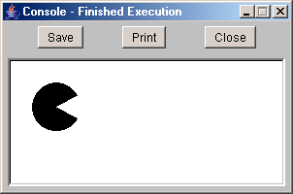

**c.fillArc (20, 20, 50, 50, 30, 300);**

Draws an arc. The arc is inscribed in the rectangle defined by the upper-left corner (*x*, *y*) with width of *width* and height of *height*. It starts at *startAngle* degrees and goes counterclockwise for *arcAngle* degrees.

**c.strokeArc** (x, y, width, height, startAngle, arcAngle)

Draws an arc outline. The arc is inscribed in the rectangle defined by the upper-left corner (*x*, *y*) with width of *width* and height of *height*. It starts at *startAngle* degrees and goes counterclockwise for *arcAngle* degrees.

**c.setFill(“rgba(red, green, blue, alpha)”)**

Sets a color using *red*, *green*, and *blue* values with an *alpha* transparency. When alpha is 1, the color is solid. When the alpha is 0, the color is totally transparent. 0.5 is half transparent, etc. Also works with c.setStroke() and c.setBackground().

## Advice: Work Small

**Keep the console window small if you can.** The console does a lot of work in the background to make things easier for you. But if you use a very large console (e.g. 1200 x 900 pixels) and do a lot of drawing, this background work can cause the app to bog down and produce memory (“Java Heap Space”) errors.

**See the handout in the “Extra” section** if you really need a large window, or if you are having memory error issues even on a small screen.